Software Requirements Document for pizzeria “Aszhan”

Author: Dream team
Serik Kenzhegalin
Ayan Khamza
Chingiz Akhmetbekov
Aibek Zholdasbekov

Version | Date | Author | Change
0.1 | 1/03/14 | Dream team | Initial Document
0.2 | 8/03/14 | Dream team | Updated with features
0.3 | 15/03/14 | Dream team | Updated features

Table of Contents
1 Introduction 3
1.1 Purpose 3
1.2 Scope 3
1.3 Definitions, acronymns, abbreviations 3
1.4 References 3
1.5 Overview 3
2 Overall Description 4
2.1 Product Perspective 4
2.2 Product functions 5
2.3 User characteristics 8
2.4 Constraints 8
2.5 Assumptions and Dependencies 8
3 Specific Requirements 8
3.1 External Interface Requirements 9
3.2 FEATURES 9
3.3 Performance requirements 11
3.4 Design Constraints 11
3.5 Software System Attributes 11
3.6 Other Requirements 11

Introduction

Purpose
The purpose of this document is to provide detailed requirements information about the LLP “Asjan” web-site

Scope
This document will describe the use cases and features of the LLP “Asjan” web-site.

Definitions, acronymns, abbreviations
// alphabetical list of terms and their descriptions
// This is part of analysis and you must make sure you describe terms used in this document
Term | Description
admin | Person who controls the website
Catering services | Catering is the business of providing food service at a remote site
Lentil soup | refers to a variety of vegetarian and meat soups made with lentils
Arlekino | A dish which consists French fries and chicken under cheese.
Viola | A dish which consists chicken with vegetables
Pizza “Asjan” | A pizza which contains kazi, cheese, tomatoes, sauce, pepper, onion

References
Wikipedia.org

Overview
[OMIT]

Overall Description

The “Asjan” site is for clients of LLP “Asjan”. The site allow clients to see all products and order pizza.

Product Perspective
It is unique, though, in that it allow to know more about this pizzeria. Our target audience is public.

Concept of Operations
Our website will run in global area network.

Major User Interfaces
See appendix

Example Screenshot and description
// <give a reference to your screens – i.e. to the APPENDIX>

Hardware Interfaces
This software requires no more than standard personal computer peripherals.

Software Interfaces
// example: CGI-URL or function signatures etc (OMIT for now).

Communication Interfaces
// example: modem etc (OMIT for now)

Memory Constraints
// RAM, and other storage constraints (OMIT for now)

Operations
// special operations (if any) (OMIT for now)

Site Adaptation Requirements
//ex: Japanese language etc (OMIT for now)

Product functions

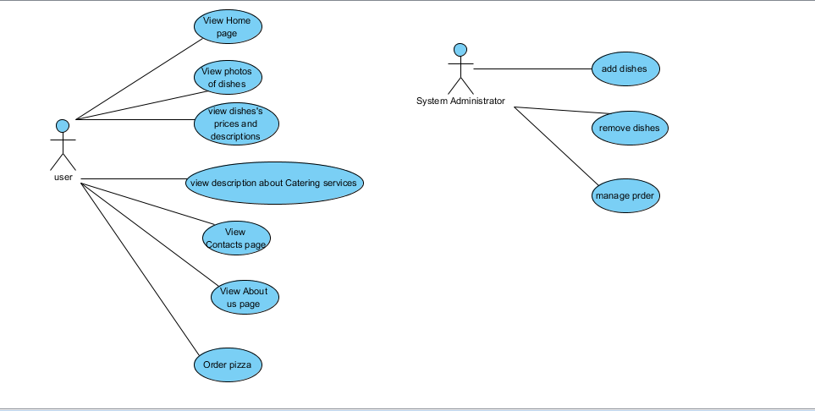

Order(SM)
Description: Allows to order pizza.
Actors: clients, system administrator

The client chooses dishes and quantity.

The client pushes the button order.

The system administrator confirms his order.

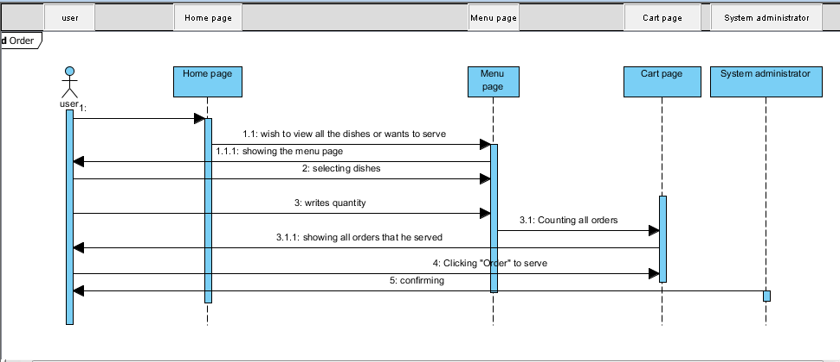

Add dishes
Description: Allows to admin add dishes
Actors: clients

Admin clicks add button

Admin full-fills name, description, adds photos

Clicks save button
Pre-condition: Admin has to click “Add” button
Post-condition: The system shows all dishes including that one he added

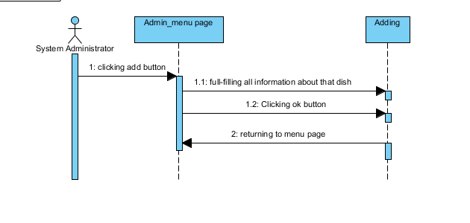

Remove dishes

Description: allows to remove dishes
Actor: admin only

Admin clicks remove button in right side of that dish

That dish is removed from list
Pre-condition: The delete is located on the top right side of each dish
Post-condition: No possibility to retrieve that dish information

User characteristics
Types | Characteristics | Frequency of usage
Admin | Controls the website, adds, removes dishes | Medium
Client | See all the dishes  order pizza | High  Medium

Constraints
1. This site is designed to be used for all the people who lives in Almaty and must be easy for all of them to use
2. This site for “Asjan” pizzeria
3. Used for watching all the dishes of that pizzeria and to order pizza
4. We are restricted to using HTML, CSS, Java EE, Database mysql

Assumptions and Dependencies
1. It is assumed that ordering will be from Halyk Bank
2. This site also depends on information of cooker of “Asjan” pizzeria

Specific Requirements

// Here you need to put in details (if any). Mark items [None] if you do not have any information.

External Interface Requirements

User Interfaces

СLASS DIAGRAM

Hardware Interfaces

Software Interfaces

Tomcat

Communications Interfaces

FEATURES

Database management

The system shall update database

Manage menu

Adding a dish

The system shall display the fields where to enter the dish’s data (name, description, cost, photos)

Error handling for adding dish

If one of these fields is empty system shall display the error message.

Inverse requirements for adding dish

The system shall not upgrade database if fields are empty.

Editing a dish

The system shall display the already filled before fields to edit dish’s data

Error handling for editing dish

The same as error handling for adding dish

Inverse requirements for editing dish

The same as inverse requirements for editing dish

Deleting dish

The system shall display button or link to delete that dish.

Order pizza

Ordering

The client shall select dishes and quantity of them and push the button “Order”.

In the cart page, system shall show all dishes that person chose.

The client shall write himself data (name, phone number and address).

The system administrator shall phone to that client who ordered and confirm his order.

Performance requirements

Usable by dial connection . Most of the postbacks must return the new page within a minute for users connected through 56k dial-up connections

Design Constraints
Html, Css, Mysql, Jsp.

Software System Attributes

Reliability

Availability

Security

Maintainability

Portability

Other Requirements

// ADD Appendices (if any)
// Regenerate Table of Contents

